Design of High Pass Filter using Windowing Techniques
5.2. Generate the coefficients of an FIR High-Pass filter using Hamming windowing techniques
Program (MATLAB Code)
clc; clear; close all;
%% --- Input Parameters ---
fp = 1000; % High-pass cutoff frequency (Hz)
fs = 8000; % Sampling frequency (Hz)
N = 50; % Filter order
wc = fp/(fs/2); % Normalized cutoff (0–1)
%% --- FIR High Pass using Hamming Window ---
b_hamm = fir1(N, wc, 'high', hamming(N+1));
disp('--- High-Pass Coefficients (Hamming Window) ---');
disp(b_hamm');
%% --- Frequency Response Plots ---
figure;
freqz(b_hamm,1);
title('High-pass FIR using Hamming Window');
title('High-pass FIR using Hanning Window');
Output
--- High-Pass Coefficients (Hamming Window) ---
-0.0007
0
0.0009
0.0016
0.0015
0
-0.0024
-0.0044
-0.0039
0
0.0060
0.0103
0.0088
0
-0.0128
-0.0217
-0.0184
0
0.0268
0.0464
0.0410
0
-0.0725
-0.1567
-0.2240
0.7493
-0.2240
-0.1567
-0.0725
0
0.0410
0.0464
0.0268
0
-0.0184
-0.0217
-0.0128
0
0.0088
0.0103
0.0060
0
-0.0039
-0.0044
-0.0024
0
0.0015
0.0016
0.0009
0
-0.0007

Fig
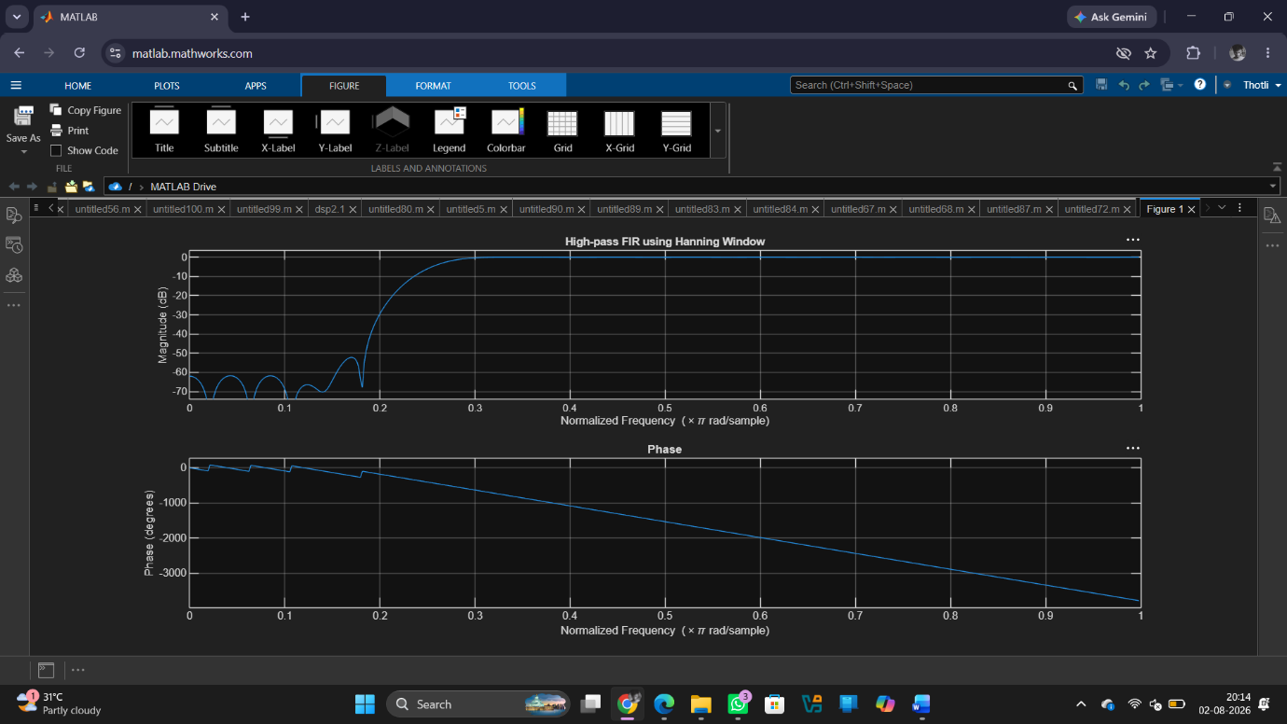

Result
1. The FIR High-Pass Filter was successfully designed using the Hamming Window technique for the specified cutoff frequency, sampling frequency, and filter order.
2. The FIR filter coefficients were successfully generated using the Hamming Window method in MATLAB and the filter was implemented.
3. The magnitude response and phase response of the designed FIR High-Pass Filter were obtained and analysed. The magnitude response showed effective attenuation of low frequency components and passage of high-frequency components, confirming the desired high-pass filtering behaviour. The phase response exhibited the expected linear-phase characteristics of an FIR filter.

